PROJECT REPORT OF INDUSTRY ORIENTED HANDS-ON EXPERIENCE (IOHE)
ON
An Integrated Multi-Approach Recommendation System for Personalized Book Discovery
submitted in partial fulfilment of the requirements for the award of degree of

BACHELOR OF ENGINEERING
In
COMPUTER SCIENCE AND ENGINEERING

Submitted by: Supervised By:
Bhawna, Deepansh, Deepanshu Aggarwal, Guransh Dr. Gifty Gupta
Roll no.’s – 2210990223, 2210990251, 2210990254, 2210990335 Mentor



DEPARTMENT OF COMPUTER SCIENCE AND ENGINEERING

CHITKARA UNIVERSITY INSTITUTE OF ENGINEERING AND TECHNOLOGY
CHITKARA UNIVERSITY, PUNJAB, INDIA

CONTENTS

S No. | Title | Page No.
 | Acknowledgement | 4
 | List of Figures and Tables | 5
1 | Introduction | 6,7
2 | Methodology | 7,8
3 | Tools and Technologies | 9
4 | Implementation | 9-12
5 | Major Findings/Outcomes/Output/Results | 13-15
6 | Conclusion and Future Scope | 15,16
 | References | 16-18

DECLARATION

I hereby certify that the work which is being presented in the project report entitled “An Integrated Multi-Approach Recommendation System for Personalized Book Discovery” in partial fulfilment of requirement for the award of the degree of Bachelor of Engineering (Computer Science and Engineering) submitted in the department of Computer Science and Engineering at Chitkara University Institute of Engineering and Technology, Chitkara University, Punjab, India, is an authentic record of my own work carried out under the supervision of Dr. Gifty Gupta. The matter presented in this project report has not been submitted in any other university/institute for the award of any degree.

Place: Rajpura Bhawna, Deepansh, Deepanshu Aggarwal, Guransh
Date: 29 April, 2026 2210990223,2210990251,2210990254, 2210990335

This is to certify that the above statement made by the candidate is correct to the best of my knowledge and belief.

Dr. Gifty Gupta
Mentor
Department of Computer Science and Engineering
Chitkara University Institute of Engineering and Technology,
Chitkara University, Punjab, India

ACKNOWLEDGEMENT

We express our sincere gratitude to Dr. Gifty Gupta, Department of Computer Science and Engineering, Chitkara University Institute of Engineering and Technology, Chitkara University, Punjab, for her invaluable guidance, constant encouragement, and continuous support throughout the course of this project titled “An Integrated Multi-Approach Recommendation System for Personalized Book Discovery.” Her expertise, insightful suggestions, and constructive feedback have been instrumental in the successful completion of this work.

We also extend our heartfelt thanks to the faculty members of the Department of Computer Science and Engineering for providing us with the necessary academic environment, resources, and support required to carry out this project effectively.

We would further like to acknowledge the cooperation and assistance of our peers, whose contributions, directly or indirectly, have been helpful during the development of this project.
Finally, we express our deep sense of gratitude to our families for their constant motivation, encouragement, and support.

We hereby declare that this project report is an authentic record of our original work carried out under the supervision of Dr. Gifty Gupta, and it has not been submitted, either wholly or in part, to any other university or institution for the award of any degree.

Place: Rajpura
Date: 29 April, 2026

Bhawna (2210990223)
Deepansh (2210990251)
Deepanshu Aggarwal (2210990254)
Guransh (2210990335)

List Of Figures

S No. | Figures | Description | Page no.
1 | Figure 1 | Workflow of the content-based filtering approach | 10
2 | Figure 2 | Collaborative Filtering Process | 10
3 | Figure 3 | Dynamic hybrid and weighted hybrid approach workflow | 11
4 | Figure 4 | Quantitative evaluation of recommendation approaches | 13
5 | Figure 5 | Performance comparison of approaches | 14
6 | Figure 6 | Heatmap representation of bias metric across approaches | 14
7 | Figure 7 | Performance representation of bias metrics | 15

- Introduction

  - Background
In recent years, the rapid expansion of digital platforms and e-commerce websites has significantly transformed the way people discover and purchase books. Online platforms such as Amazon, Flipkart, and various digital libraries provide access to an enormous collection of books across multiple genres, languages, and formats. While this has improved accessibility and convenience for users, it has also led to a major challenge known as information overload, where users are overwhelmed by the sheer volume of available options.
In such an environment, it becomes difficult for users to identify books that align with their interests and preferences. This challenge highlights the importance of recommendation systems, which aim to filter and present relevant content to users based on their behavior, preferences, and interactions.
Traditional recommendation techniques such as Content-Based Filtering (CBF) and Collaborative Filtering (CF) have been widely used to address this problem. Content-based filtering recommends items similar to those previously liked by the user, while collaborative filtering relies on user interaction data to suggest items based on similar users' preferences.
However, these traditional approaches suffer from several limitations, including:
- Cold-start problem: Difficulty in recommending items to new users or for new items with no prior data
- Data sparsity: Insufficient user-item interaction data affecting recommendation quality
- Popularity bias: Over-recommendation of popular or frequently rated items
- Lack of diversity: Repetitive suggestions limiting exploration
To overcome these challenges, this research proposes an integrated multi-approach recommendation system that combines multiple techniques to improve recommendation accuracy, personalization, and fairness.

  - Problem Statement
Despite the availability of recommendation systems, existing models are not fully effective in delivering high-quality personalized book suggestions. The major problems identified are:
- Inability to handle new users and new books efficiently
- Poor performance due to sparse datasets
- Bias toward highly popular books, ignoring niche content
- Lack of adaptability to individual user preferences
These issues reduce user satisfaction and limit the effectiveness of recommendation systems. Therefore, there is a need for a more advanced and flexible recommendation framework that can address these limitations.

  - Objective
The main objective of this research is to design and develop an efficient and intelligent book recommendation system that can provide accurate, personalized, and fair suggestions to users. The study focuses on improving existing recommendation techniques by combining multiple approaches into a single framework.
The specific objectives of the study are as follows:
- To develop a multi-approach recommendation system that integrates content-based filtering, collaborative filtering, and hybrid techniques for better performance.
- To enhance the accuracy of recommendations so that users receive more relevant and meaningful book suggestions based on their interests.
- To improve the ranking quality of recommended books using advanced evaluation metrics such as Precision, Recall, MAP, and NDCG.
- To reduce common issues like the cold-start problem and data sparsity, which affect the performance of traditional recommendation systems.
- To minimize popularity bias, ensuring that less popular or new books also get recommended, instead of only well-known bestsellers.
- To improve personalization by adapting recommendations based on individual user preferences and past interactions.
- To implement a dynamic hybrid model that adjusts the importance (weights) of different recommendation techniques according to user behavior.
- To evaluate the system using multiple performance metrics and analyze the balance between accuracy, diversity, and fairness in recommendations.

- Methodology
The methodology describes the overall process followed to design and develop the proposed book recommendation system. It includes dataset selection, preprocessing, implementation of different recommendation techniques, and evaluation of system performance. The approach focuses on combining multiple recommendation strategies to improve accuracy, personalization, and fairness.

  - Dataset
The dataset used in this study is the Book-Crossing dataset, which is widely used in recommendation system research. It contains real-world data related to books and user interactions, making it suitable for building and evaluating recommendation models.
The dataset consists of three main components: books data, user data, and ratings data. The books dataset includes details such as title, author, and publisher. The ratings dataset represents user interactions in the form of ratings given to books, while the users dataset contains basic information like user ID, age, and location.
This dataset is particularly useful because it allows the implementation of both content-based and collaborative filtering techniques. Its large size also helps in simulating real-world recommendation scenarios, similar to those used in e-commerce platforms.

  - Data Preprocessing
Data preprocessing is an important step to ensure that the dataset is clean, consistent, and suitable for analysis. Initially, the dataset was examined for missing values and inconsistencies. Missing or irrelevant data entries were removed or handled appropriately to improve data quality.
The three datasets (books, users, and ratings) were then merged to create a unified structure that could be used for model building. Unnecessary attributes were removed, and only relevant features such as book title, author, and user ratings were retained.
In addition, steps were taken to reduce data sparsity by filtering out users or books with very few interactions. Standardization techniques were also applied to ensure consistency in data representation. These preprocessing steps significantly improved the efficiency and performance of the recommendation models.

  - Recommendation Techniques
    - Content-Based Filtering
Content-based filtering recommends books based on their similarity to previously liked books. In this approach, textual information such as book titles and authors is converted into numerical form using TF-IDF. Cosine similarity is then used to measure the similarity between books. This method provides highly personalized recommendations but may result in repetitive suggestions, as it focuses mainly on user history.
    - Collaborative Filtering
Collaborative filtering generates recommendations based on user interaction patterns. It assumes that users with similar preferences are likely to enjoy similar books. A user-item matrix is created using ratings data, and techniques like Truncated SVD are applied to reduce sparsity and improve prediction accuracy. Although effective in discovering new items, this method suffers from cold-start and data sparsity issues.
    - Dynamic Weighted Hybrid Filtering
The dynamic hybrid model further enhances the hybrid approach by adjusting weights dynamically based on user preferences. Instead of using fixed weights, the system adapts according to user behavior, giving more importance to the method that performs better for a particular user. This results in more flexible and personalized recommendations.
    - Hybrid Filtering
Hybrid filtering combines the strengths of both content-based and collaborative filtering. Recommendation scores from both methods are calculated separately and then combined using a weighted approach. This method improves overall accuracy and reduces the limitations of individual techniques, providing a better balance between personalization and diversity.

  - Evaluation Metrics
The performance of the proposed recommendation system is evaluated using a combination of accuracy-based, ranking-based, and bias-related metrics to ensure overall effectiveness.
Accuracy measures the overall correctness of the recommendations by identifying how many suggested books match user preferences. Precision evaluates the quality of recommendations by calculating the proportion of relevant books among the recommended ones, while Recall measures the system’s ability to retrieve all relevant books for a user.
To assess ranking quality, MAP (Mean Average Precision) and NDCG (Normalized Discounted Cumulative Gain) are used. These metrics consider the position of relevant items in the recommendation list, giving higher importance to books that appear at the top, thus improving user experience.
In addition to accuracy and ranking, fairness is also considered through bias metrics. Popularity Bias checks whether the system disproportionately recommends popular books, while Thematic Bias ensures that the recommendations align with the user’s interests and reading patterns.

- Tools and Technologies
The implementation of the system utilized the following tools and technologies:
- Programming Language: Python
- Libraries: Pandas, NumPy, Scikit-learn, Matplotlib
- Techniques: TF-IDF, Cosine Similarity, Truncated SVD
- Dataset Source: Kaggle (Book-Crossing Dataset)
- Environment: Jupyter Notebook / Google Colab

- Implementation
The implementation of the proposed book recommendation system was carried out in multiple stages, including data preprocessing, model building, and generation of recommendations. Different recommendation techniques were implemented individually and later combined to form a hybrid system.

  - Content-Based Filtering
Content-based filtering recommends books by analyzing their features such as title, author, and publisher. The textual data is converted into numerical form using TF-IDF, which captures the importance of words. A user profile is created by averaging vectors of previously liked books, and cosine similarity is used to find similar books for recommendation.

tfidf = TfidfVectorizer()
item_matrix = tfidf.fit_transform(books_filtered['content_text'])
scores = cosine_similarity(user_profile, item_matrix)

Formulas:
$$TF\text{-}IDF(t,d)=TF(t,d)×log⁡\left(\frac{N}{df(t)}\right) \\ Similarity(A,B)=\frac{A⋅B}{∣∣A∣∣⋅∣∣B∣∣} \\ User_Profile=\frac{1}{n}∑V_{i}$$
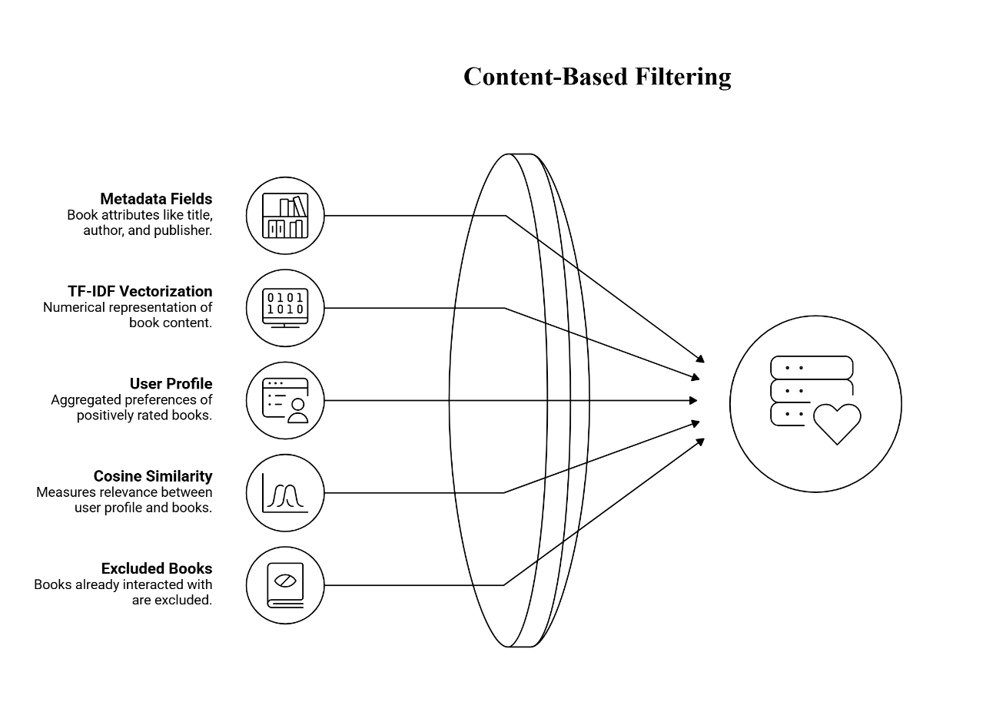
Figure 1 Workflow of the content-based filtering approach
  - Collaborative Filtering
Collaborative filtering uses user interaction data (ratings) to recommend books. A user-item matrix is constructed, and Truncated SVD is applied to reduce sparsity and capture hidden relationships between users and items. The model then predicts missing ratings and recommends books with the highest predicted values.

matrix = csr_matrix((values, (row_idx, col_idx)))
svd = TruncatedSVD(n_components=50)
pred_matrix = np.dot(user_factors, item_factors.T)

Formulas:
$$R≈UΣV^{T} \\ \hat{R}=U⋅V^{T}$$

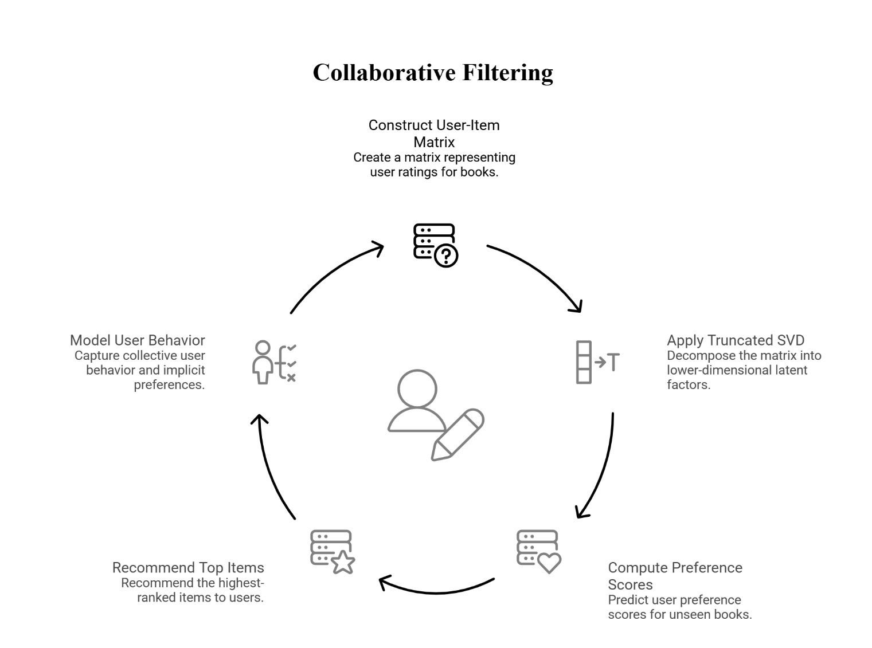
Figure 2 Collaborative Filtering process showing user–item matrix construction, SVD-based dimensionality reduction, and generation of top-N recommendations
  - Hybrid Filtering
Hybrid filtering combines content-based and collaborative filtering to improve recommendation accuracy. Scores from both methods are calculated and merged using a weighted approach, allowing the system to balance personalization and user behavior effectively.
score = content_weight*(1/(rank+1)) + collaborative_weight*(1/(rank+1))

Formula:
$$Score(i)=w_{c}⋅Score_{content}(i)+w_{cf}⋅Score_{collab}(i)$$
where:
$$w_{c}=0.7, w_{cf}=0.3$$
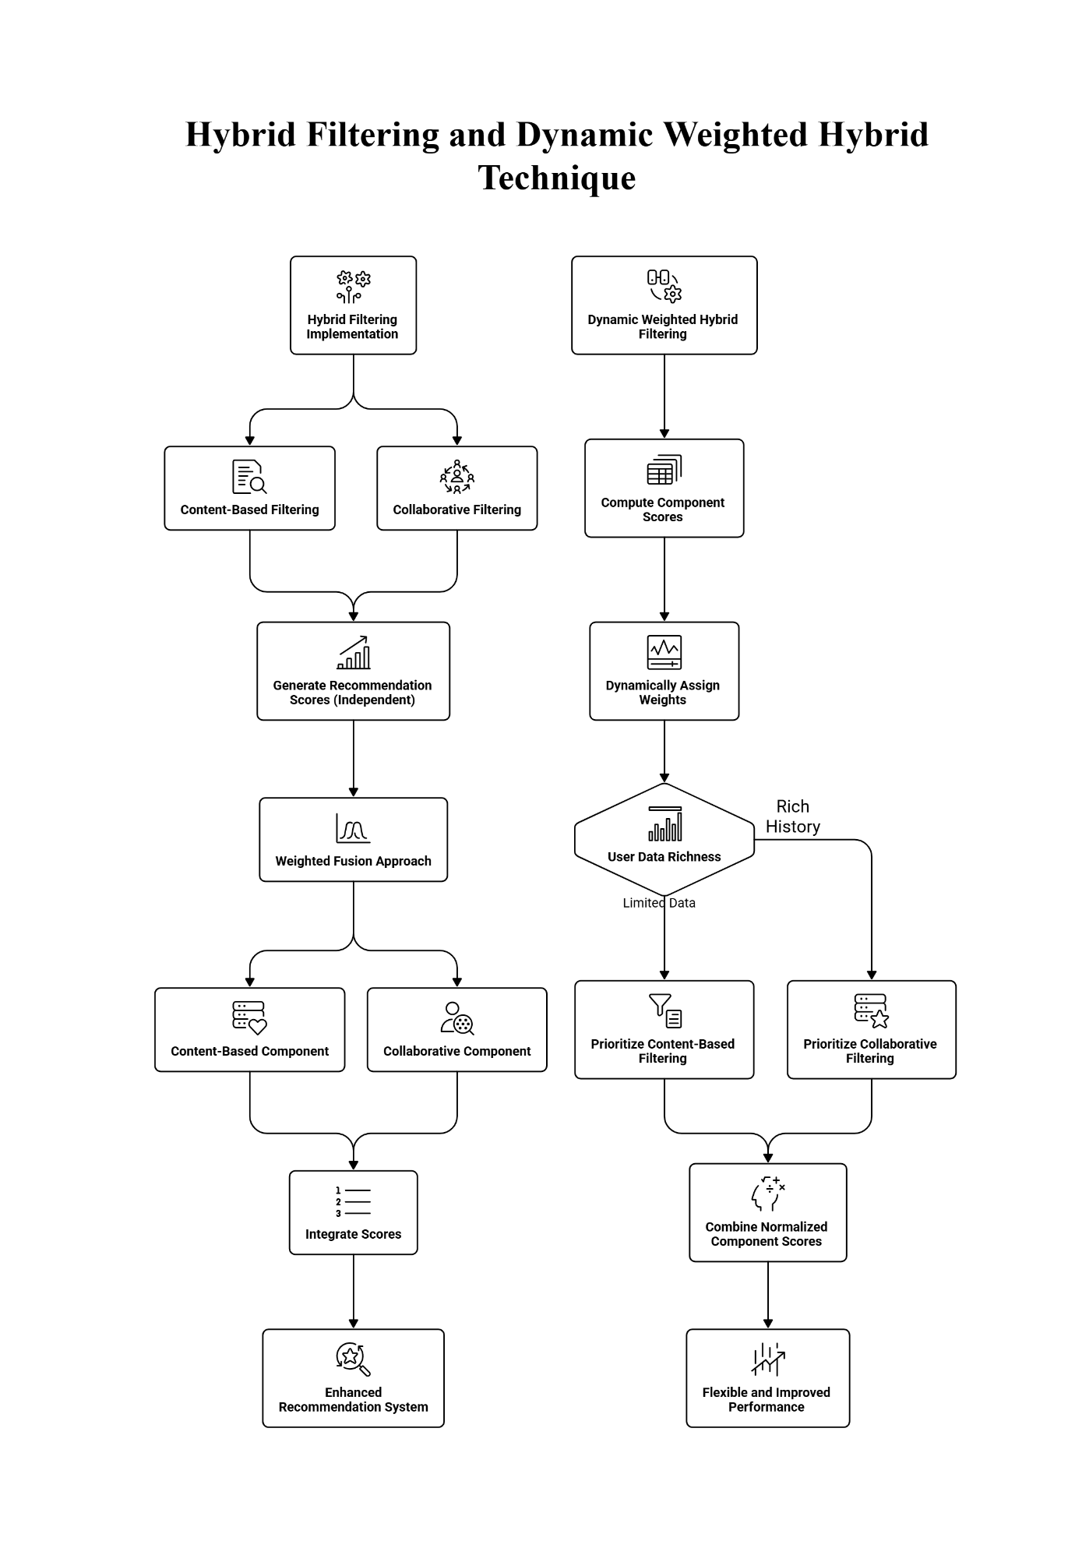

Figure 3 Hybrid filtering and Dynamic Hybrid Filtering framework combining content-based and collaborative filtering using a weighted fusion approach for enhanced recommendations.

  - Dynamic Weighted Hybrid Filtering
This model improves the hybrid approach by dynamically adjusting weights based on user interaction history. It combines content-based, collaborative, and popularity scores, ensuring better adaptability for both new and active users.

final_scores[isbn] = ( w_content * content_scores + w_collab * collab_scores + w_pop * popularity_scores
)
Formula:
$$Score(i)=w_{c}S_{c}(i)+w_{cf}S_{cf}(i)+w_{p}S_{p}(i)$$

  - Evaluation Metrics
The performance of the proposed recommendation system is evaluated using a combination of accuracy-based and ranking-based metrics. These metrics are computed by comparing the recommended books with the actual user preferences from the test dataset.
Accuracy is calculated as the average of precision and recall, representing the overall correctness of the recommendations:
$$Accuracy=\frac{Precision+Recall}{2}$$
Precision measures the proportion of recommended books in the top-K list that are relevant:
$$Precision=\frac{\text{Number of relevant recommended items}}{K}$$
Recall measures how many relevant books are successfully retrieved from all relevant items:
$$Recall=\frac{\text{Number of relevant recommended items}}{\text{Total relevant items}}$$
MAP (Mean Average Precision) evaluates the ranking quality by considering the positions of relevant items in the recommendation list:
$$MAP=\frac{1}{N}∑AP$$
NDCG (Normalized Discounted Cumulative Gain) measures how well relevant items are ranked higher in the recommendation list:
$$NDCG@K=\frac{DCG}{IDCG}$$
To provide an overall comparison of models, a Composite Score is calculated as a weighted combination of different metrics:

$$Composite Score=0.40⋅NDCG+0.30⋅MAP+0.20⋅Precision+0.10⋅Recall$$
Based on the evaluation results, the Hybrid Approach achieved the highest performance across most metrics, including Accuracy (0.0441), Precision (0.0080), Recall (0.0801), MAP (0.0313), and NDCG (0.0427). The Content-Based model showed good personalization but slightly lower ranking performance, while the Collaborative Filtering model performed the weakest due to sparse data. The Dynamic Weighted Hybrid model showed moderate performance but did not outperform the standard hybrid approach.

- Major Findings/ Results
The performance of the proposed recommendation system was evaluated using multiple accuracy-based and ranking-based metrics, along with bias analysis to ensure fairness and effectiveness.

  - Performance Analysis
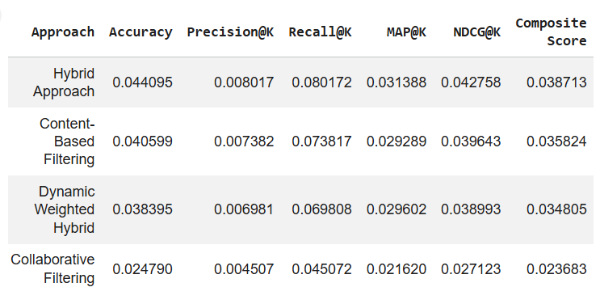
The performance analysis of the proposed recommendation system shows that the Hybrid Approach achieved the best overall results across all evaluation metrics. It obtained the highest Accuracy (0.0441), Precision (0.0080), Recall (0.0802), MAP (0.0314), and NDCG (0.0428), indicating a strong balance between recommendation accuracy and ranking quality. The Content-Based Filtering model performed well in terms of coverage (0.8668) and personalization (0.9982), demonstrating its ability to generate diverse and user-specific recommendations, although its ranking performance was lower than the hybrid model. The Dynamic Weighted Hybrid model showed moderate performance but did not outperform the standard hybrid approach, suggesting that adaptive weighting did not significantly improve results in this case. The Collaborative Filtering model showed the weakest performance, with the lowest Precision (0.0045), Recall (0.0451), and Accuracy (0.0248), mainly due to sparsity in the user-item interaction data. Overall, the results clearly indicate that the hybrid model provides the most effective and balanced recommendation performance among all approaches.
Figure 4 Quantitative evaluation of recommendation approaches showing Accuracy, Precision, Recall, MAP, NDCG, and composite score for each model

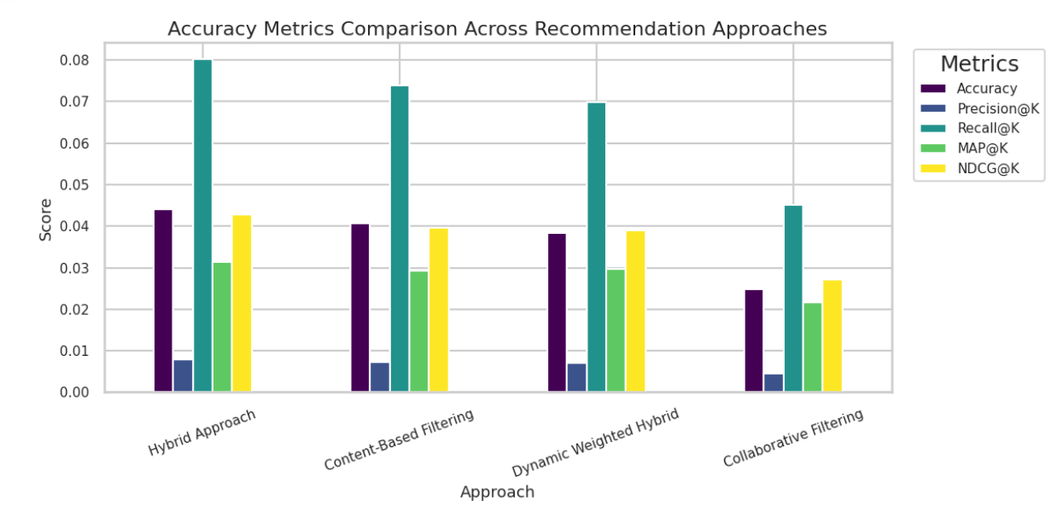
Figure 5 Performance comparison of recommendation approaches based on accuracy metrics
  - Bias Analysis
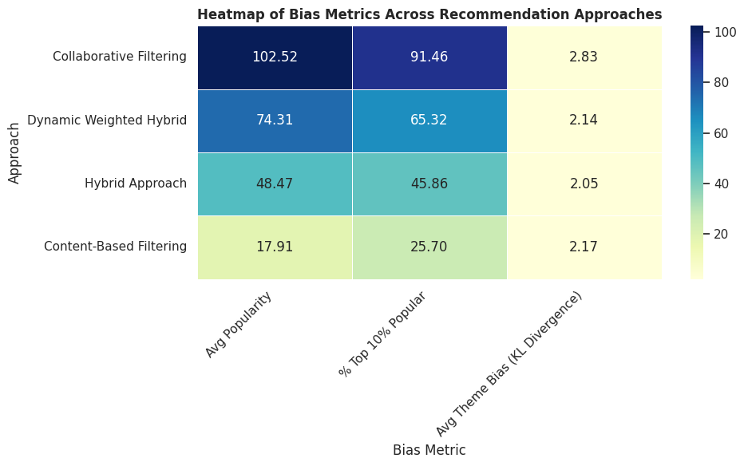
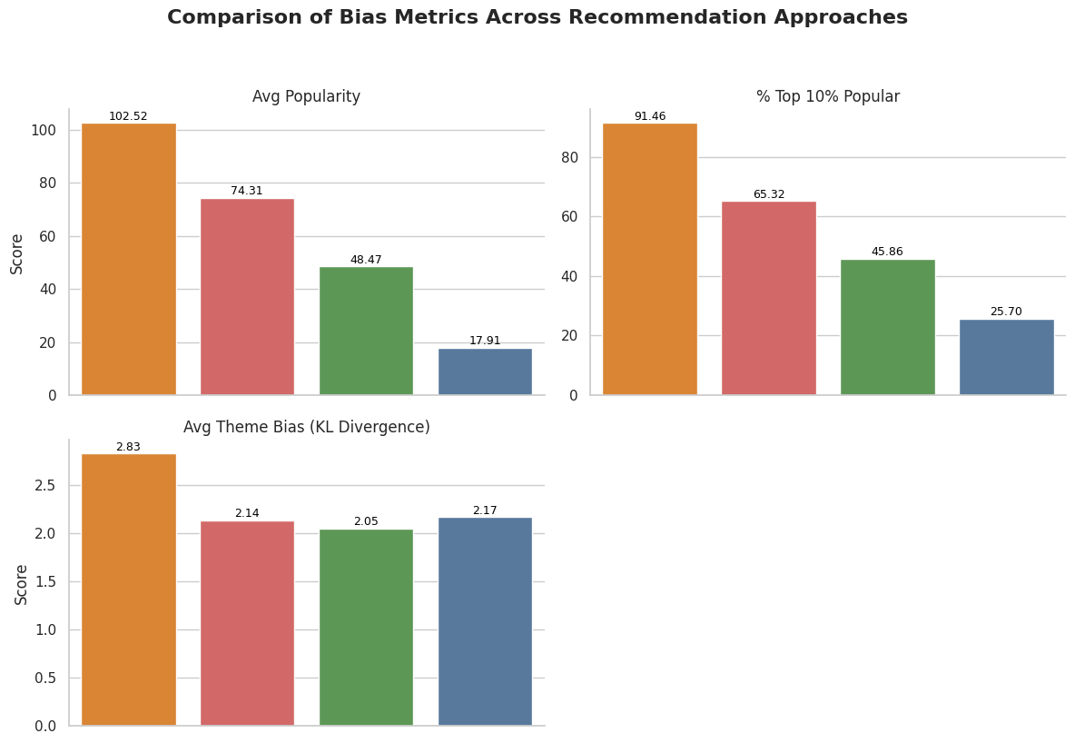
The bias analysis of the recommendation models highlights clear differences in how each approach handles popularity and thematic relevance. The Collaborative Filtering model showed the highest popularity bias, with approximately 91.46% of its recommendations coming from the top 10% most popular books, indicating a strong tendency to favor popular items. In contrast, the Content-Based Filtering model exhibited very low popularity bias, recommending a wider range of books, including less popular ones, which improves diversity. The Hybrid Approach provided a balanced performance, reducing popularity bias while still maintaining strong recommendation accuracy. For thematic consistency, KL-divergence was used to measure how closely recommendations match user interests. The Hybrid model achieved the lowest divergence (2.0513), indicating better alignment with user preferences, while the Collaborative Filtering model showed the highest divergence (2.8316), suggesting weaker thematic consistency.
Figure 6 Heatmap Representation of bias metrics across recommendation approaches.
Figure 7 Performance Comparison of Bias Metrics across Recommendation approaches
Overall, the results demonstrate a clear trade-off between different recommendation approaches. Content-Based Filtering excels in diversity and personalization, but lacks strong ranking performance. Collaborative Filtering suffers from data sparsity and high popularity bias, which reduces its effectiveness. The Hybrid Approach successfully combines the strengths of both methods, achieving the best balance between accuracy, ranking quality, personalization, and fairness. Therefore, the hybrid model emerges as the most effective recommendation strategy for practical applications.

- Conclusion and Future Scope
  - Conclusion
This research presents a multi-approach book recommendation system that integrates content-based filtering, collaborative filtering, and hybrid techniques to improve recommendation quality. The experimental results clearly demonstrate that the Hybrid Approach performs the best across most evaluation metrics, achieving higher accuracy, better ranking quality, and improved balance between personalization and bias control.
While Content-Based Filtering proved effective in providing diverse and highly personalized recommendations, it lacked strong ranking performance. On the other hand, Collaborative Filtering suffered from data sparsity and showed high popularity bias, which reduced its effectiveness. The Dynamic Weighted Hybrid model introduced adaptability but did not significantly outperform the standard hybrid model under the given conditions.
Overall, the Hybrid Recommendation Model successfully combines the strengths of different approaches, resulting in a more accurate, fair, and reliable recommendation system. Therefore, it can be considered a suitable solution for real-world applications in e-commerce platforms and digital libraries

  - Future Scope
Although the proposed system shows promising results, there are several areas where further improvements can be made. Future work can focus on enhancing the recommendation system by incorporating more advanced techniques and real-time data.
- Integration of deep learning models such as neural networks to improve prediction accuracy
- Use of real-time user interaction data for dynamic and adaptive recommendations
- Improvement of dynamic weighting strategies for better performance
- Inclusion of multilingual and regional datasets to support diverse users
- Incorporation of sentiment analysis and user reviews for better understanding of preferences
- Development of a user-friendly interface for practical deployment
In future, the system can be extended to provide more intelligent, scalable, and context-aware recommendations, making it more suitable for large-scale real-world applications.

References
[1] Subudhi, K. A. (2025). A Hybrid Book Recommendation Framework to Address the Cold Start Problem Using Weighted Fusion of Content-Based and Collaborative Filtering. https://ieeexplore.ieee.org/document/11388983/

[2] Gupta, U. et al. (2025). Book Recommendation System Using Hybrid Content and Collaborative Filtering Techniques.
https://ieeexplore.ieee.org/document/10986667/

[3] Jayapal, C. et al. (2023). Book Recommendation System Using Hybrid Filtering. https://ieeexplore.ieee.org/document/10199590/

[4] Chen, Y. et al. (2025). Research on Book Recommendation Integrating Collaborative Filtering and Improved Algorithms.
https://ieeexplore.ieee.org/document/10967261/

[5] Rahman, M. M. (2024). Hybrid recommendation systems using adaptive clustering to address cold start problems.
https://ieeexplore.ieee.org/document/10698666

[6] Shukla, N., et al. (2022). Online book recommendation system using custom collaborative and content-based filtering.
https://ieeexplore.ieee.org/document/9777131/

[7] Roy, T., et al. (2024). A hybrid approach to predict ratings for book recommendation system using machine learning techniques.
https://ieeexplore.ieee.org/document/10752128/

[8] Cheng, L. (2024). Optimization of the Book Recommendation System Based on Collaborative Filtering.
https://ieeexplore.ieee.org/document/10839670/

[9] Pagadala, M. et al. (2024). Generating Book Suggestions Using a Hybrid Model with Sentiment Analysis.
https://ieeexplore.ieee.org/document/10627899/

[10] Samridhi, K. et al. (2024). Optimizing User Recommendations with Variational Autoencoders: Insights from MovieLens-1M and Book Crossing Datasets. https://ieeexplore.ieee.org/document/10782360/

[11] Zaizi, F. E. et al. (2023). A Comparative Study of Evolutionary Algorithms for Multi-Objective Recommender Systems.
https://ieeexplore.ieee.org/document/10308781/

[12] Husaeni, M. I. Z. et al. (2023). Boosting the Performance of Hybrid Semantic Ontology-based model using Density Rough k-Modes Clustering Technique on Library Book Recommendation System.
https://ieeexplore.ieee.org/document/10427018/

[13] Verma, P. (2025). Recommendation System for books using Graph Neural Networks. https://ieeexplore.ieee.org/document/11011901/
[14] X. Su and T. M. Khoshgoftaar, “A Survey of Collaborative Filtering Techniques,” IEEE Computer, vol. 42, no. 8, pp. 30–37, 2009.

[15] G. Adomavicius and A. Tuzhilin, “Toward the Next Generation of Recommender Systems: A Survey of the State-of-the-Art and Possible Extensions,” IEEE Transactions on Knowledge and Data Engineering, vol. 17, no. 6, pp. 734–749, 2005.

[16] Y. Koren, R. Bell, and C. Volinsky, “Matrix Factorization Techniques for Recommender Systems,” IEEE Computer, vol. 42, no. 8, pp. 30–37, 2009.

[17] H. Steck, “Item Popularity and Recommendation Accuracy,” in Proc. ACM Conference on Recommender Systems (RecSys), 2011.

[18] S. Rendle et al., “BPR: Bayesian Personalized Ranking from Implicit Feedback,” in Proc. UAI, 2009.

[19] P. Covington, J. Adams, and E. Sargin, “Deep Neural Networks for YouTube Recommendations,” in Proc. ACM RecSys, 2016.

[20] J. Bobadilla, F. Ortega, A. Hernando, and A. Gutiérrez, “Recommender Systems Survey,” Knowledge-Based Systems, vol. 46, pp. 109–132, 2013.

[21] C. Aggarwal, *Recommender Systems: The Textbook*, Springer, 2016.

[22] S. Funk, “Netflix Update: Try This at Home,” 2006. (SVD-based recommendation breakthrough)

[23] M. Deshpande and G. Karypis, “Item-Based Top-N Recommendation Algorithms,” ACM Transactions on Information Systems, vol. 22, no. 1, pp. 143–177, 2004.

[24] H. Wang et al., “Collaborative Deep Learning for Recommender Systems,” in Proc. ACM SIGKDD, 2015.

[25] L. Baltrunas and X. Amatriain, “Towards Time-Dependent Recommendation Based on Implicit Feedback,” RecSys, 2009.

